**Moderation Analysis with SPSS Process**

Bring the data into SPSS.

Double click the Process.sps file. It will open in a new syntax window. Run it.

If desired, standardize the continuous variables.

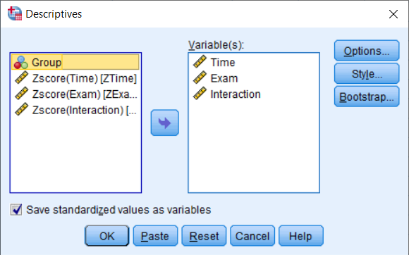

File, New, Syntax. Write the Process code:

**process y=ZExam/x=ZTime/w=Group/model=1/plot=1.**

Run the syntax.

***************** PROCESS Procedure for SPSS Version 3.4 *****************

Written by Andrew F. Hayes, Ph.D. www.afhayes.com

Documentation available in Hayes (2018). www.guilford.com/p/hayes3

**************************************************************************

Model : 1

Y : ZExam

X : ZTime

W : Group

Sample

Size: 200

**************************************************************************

OUTCOME VARIABLE:

ZExam

Model Summary

R R-sq MSE F df1 df2 p

.8674 .7525 .2513 198.5912 3.0000 196.0000 .0000

Model

coeff se t p LLCI ULCI

constant -.8216 .0509 -16.1378 .0000 -.9220 -.7212

ZTime .2586 .0487 5.3114 .0000 .1626 .3546

Group 1.6894 .0721 23.4241 .0000 1.5472 1.8317

Int_1 .2540 .0727 3.4945 .0006 .1106 .3973

Product terms key:

Int_1 : ZTime x Group

Test(s) of highest order unconditional interaction(s):

R2-chng F df1 df2 p

X*W .0154 12.2117 1.0000 196.0000 .0006

----------

Focal predict: ZTime (X)

Mod var: Group (W)

Conditional effects of the focal predictor at values of the moderator(s):

Group Effect se t p LLCI ULCI

.0000 .2586 .0487 5.3114 .0000 .1626 .3546

1.0000 .5125 .0540 9.4987 .0000 .4061 .6190

Data for visualizing the conditional effect of the focal predictor:

Paste text below into a SPSS syntax window and execute to produce plot.

DATA LIST FREE/

ZTime Group ZExam .

BEGIN DATA.

-1.0568 .0000 -1.0948

.1311 .0000 -.7877

1.0615 .0000 -.5471

-1.0568 1.0000 .3262

.1311 1.0000 .9350

1.0615 1.0000 1.4119

END DATA.

GRAPH/SCATTERPLOT=

ZTime WITH ZExam BY Group .

*********************** ANALYSIS NOTES AND ERRORS ************************

Level of confidence for all confidence intervals in output:

95.0000

------ END MATRIX -----